LAB SESSION 2
Task 1: Creating the Tables (DDL)
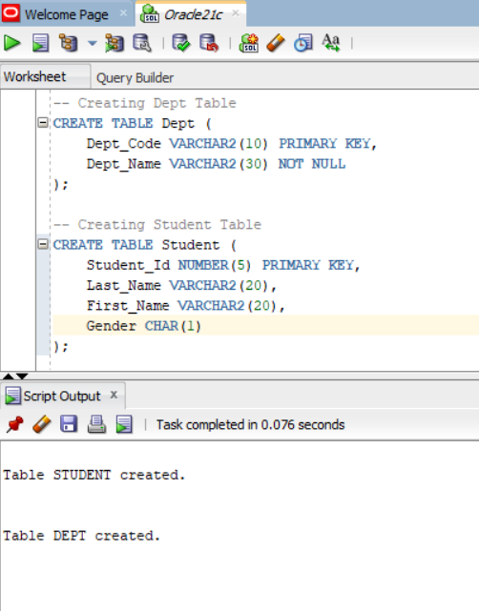

Task 2: Modifying Structure (ALTER)
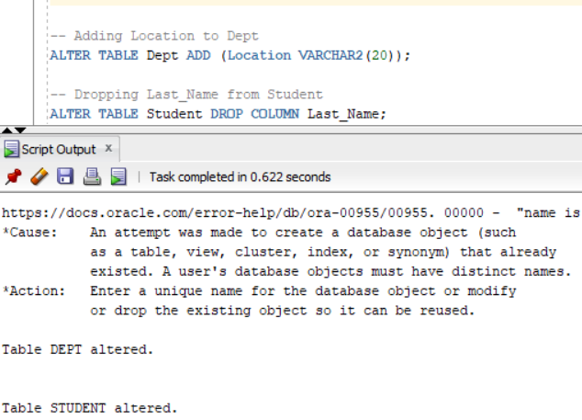

Task 3: Verifying the Structure (DESC)
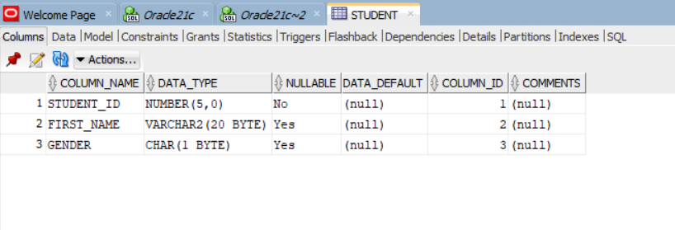

Task 4: Data Entry & Arithmetic (DML)
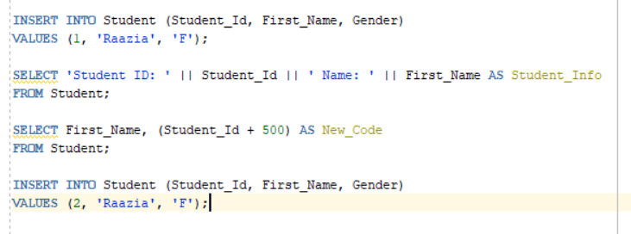

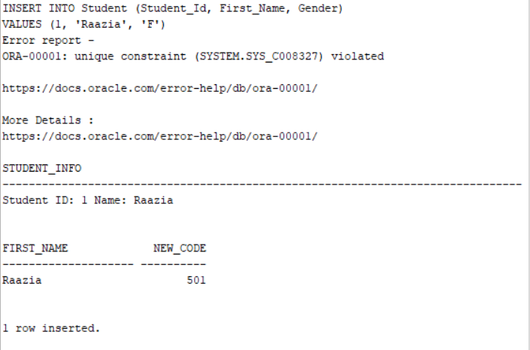

Task 5: Finalizing (Commit & Drop)
